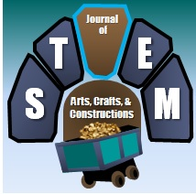 | Journal of STEM Arts, Crafts, and Constructions
Student and Student’s Work Photograph Release Form
Students over the age of 18 may sign for themselves; students under 18 must have this release signed by their parent or guardian.
I hereby consent to the use of this photograph or video of my child/dependent/self, or child’s work/ dependent’s work/ or my work, and/or any copies of this photograph or video in any editorial and/or promotional material produced and/or published by the Journal of STEM Arts, Crafts, and Constructions.
I understand that signing this release does not guarantee publication of the photo.

Name of student or student whose work is shown in the photo or video

_____________________________________________

Name (if age 21 or older) or Parent/Guardian Name

_____________________________________________

Signature (if age 21 or older) or Signature of Parent/Guardian

_____________________________________________

Date: _______________

